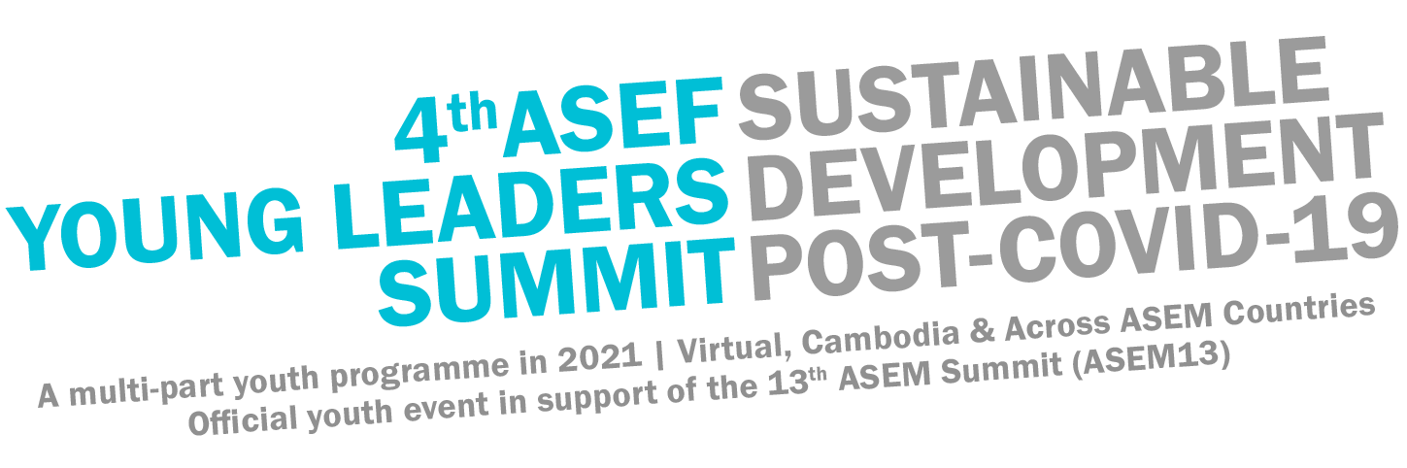
4th ASEF Young Leaders Summit (ASEFYLS4)
“Sustainable Development Post-COVID-19”
A multi-part youth programme in 2021
Virtual, Cambodia & Across ASEM Countries
Official youth event in support of the 13th ASEM Summit (ASEM13)
Overview (Screen Reader-Friendly version)
Project: 4th ASEF Young Leaders Summit (ASEFYLS4)
Official youth event in support of the 13th Asia-Europe Meeting (ASEM) Summit (ASEM13)
Theme: Sustainable Development in a Post-COVID-19 World

Timings: 10-month long youth leadership programme
Monday, 22 February 2021 until the end of November 2021

Background on the ASEFYLS Series:

The ASEF Young Leaders Summit (ASEFYLS) is a platform that connects young people with the Heads of States and Governments of 51 Asian & European countries and the political Leaders of the EU & the ASEAN Secretariat. Held biennially as the official youth event in support of Asia-Europe Meeting (ASEM) Summits, the ASEFYLS is a thought & action arena for young people with a 360° approach on leadership development and community engagement: from a self, team and societal perspective.

See what the ASEFYLS is all about in this trailer!

5 Pillars of ASEFYLS:

- Building Knowledge: Knowledge foundation and toolkit for action to gain rewarding insights and to inspire both recognised and unsung young leaders
- Reciprocity: Peer-to-peer learning and sharing of time, talent & resources for personal growth in a team environment
- Diversity of Network: Space to create partnerships across sectors: youth, community leaders, responsible business leaders, thought-provoking academics and political leaders across 51 countries
- Leadership Dialogue: Personal dialogues and exchanges with Heads of States and political leaders on leadership principles & ethical decision- making towards the Agenda2030
- Coillaboration: Commitment to collaborate on “Leadership in Action” activities on sustainable development in local communities

Upcoming Edition: ASEFYLS4:

The 4th ASEF Young Leaders Summit (ASEFYLS4) is a 10-month long youth leadership programme connected with the 13th ASEM Summit (ASEM13) in Cambodia. The ASEFYLS4 focuses on ‘Sustainable Development in a post-COVID-19 World’ and incorporates 3 spheres for youth leadership:
1) self-leadership (you), 2) team leadership (we) and 3) societal leadership (all).

The 4th edition will be a hybrid project with collaborative programme elements taking place virtually, in Cambodia & Singapore, as well as across ASEM countries. The project addresses 4 thematic areas:

1. SDG3: Good Health & Wellbeing: Ensure healthy lives and promote well-being for all at all ages
2. SDG4: Quality Education: Ensure inclusive and equitable quality education and promote lifelong learning opportunities for all
3. SDG8: Decent Work & Economic Growth: Promote sustained, inclusive and sustainable economic growth, full and productive employment and decent work for all
4. SDG13: Climate Action: Take urgent action to combat climate change and its impacts

These goals are selected based on significant areas of impact the COVID-19 crisis have had on young people, the learnings from the current crisis they can bring to the discussion table, and areas in which they can contribute to, with an aim to build a more resilient society.

The ASEFYLS4 consists of 3 Programme Phases:

- Knowledge Building: Mon, 22 February 2021 - Fri, 28 May 2021, Virtual
- Youth Summit at the 13th ASEM Summit: Sat, 29 May 2021 - Wed, 2 June 2021, On-site in Cambodia/Virtual*
- Leadership in Action: June - November 2021, Virtual & On-site in local ASEM communities

The ASEFYLS4 welcomes up to 150 youth leaders from diverse academic disciplines and professional backgrounds, who are selected through an Open Call for Application process.
ASEF’s programmes are inclusive and ensure a gender and geographical balance. We do not discriminate against any applicant or participant based on gender, sexual orientation, disability, age, colour, ethnicity/race, national origin (ancestry), religion (creed), or marital status.

The ASEFYLS4 is organised by the Asia-Europe Foundation, the Ministry of Foreign and International Cooperation of the Kingdom of Cambodia (MFAIC), the Ministry of Education, Youth and Sport of the Kingdom of Cambodia (MOEYS), the Ministry of Commerce of the Kingdom of Cambodia, and the APSARA National Authority of the Kingdom of Cambodia.
Our project partners are: the Union Youth Federations of Cambodia (UYFC), College of Europe Natolin, and the Center for Creative Leadership.
Our project supporters are: Global Changemakers, Erasmus Student Network (ESN), European Students Union (ESU), International Association For Political Science Students (IAPSS).
ASEF’s contribution is made possible with the financial support of the European Union.

Note: The Cambodia on-site event is pending local and international public health & safety guidelines, as well as travel recommendations.
Project Cycle:

The ASEFYLS4 Project Cycle began back 2020, with the ASEFYLS4 Navigators Training from 4 September to 4 December 2020. This is followed by the ASEFYLS4 Open Call, which opens on 15 January 2021 and ends on 3 February 2021.

The programme of ASEFYLS4 is designed to take place alongside, and feed into, the ASEM Governmental Process:

- During the ASELFYLS4 Virtual Knowledge Building & Collaboration Phase from 22 February to 28 May 2021, participants will be given the chance to have dialogues with ASEM Political Leaders.
- The ASEFYLS4 Summit from 29 May to 2 June 2021 will take place alongside the 13th ASEM Summit, where participants may have the chance to interact with Political Leaders and Ministers representing ASEM countries on the sidelines of the event.
- The Leadership in Action Activities phase from June to November 2021 will take place alongside the 8th ASEM Education Ministers’ Meeting (ASEMME8) to be confirmed.
- During the ASEFYLS4 Navigators Debrief, participants will be invited to a roundtable with ASEF/ASEM Officials to share with them what they have learnt and report on the Leadership in Action Activities.

Details on the Programme Phases:

About 150 youth representatives – at least 1 representative of each 51 ASEM Partner country – are selected through an Asia-Europe wide Open Call to join the ASEFYLS4, which is built on 3 Programme Phases:
1) Knowledge Building (22 February – 28 May 2021)

Through e-learning and virtual collaboration platforms, the ASEFYLS4 Knowledge Building phase fuses theory, training and policy and integrates 4 elements:
- Thematic Course with a certification, focusing on Asia-Europe and international relations in the context of the Sustainable Development Goals (SGD3, 4, 8 and 13), led by College of Europe Natolin in partnership with ASEF
- A Leadership Training with a certification, exploring Self, Team & Societal leadership, led by the Center for Creative Leadership in partnership with ASEF
- Youth Dialogues with ASEM Leaders (Heads of States and Governments) on the SDGs, moderated by ASEFYLS4 participants
- Focus Group Discussions & Collaboration on leadership, the SDGs & the Leadership in Action projects, led by ASEFYLS4 Navigators.

Find out more about the Knowledge Building programme here.
2) ASEFYLS4 Youth Summit (29 May – 2 June 2021)

The Youth Summit will either take place fully virtually, or should local and international health, safety and travel guidelines allow – as a hybrid event with both virtual as well as on-site programme elements in Cambodia alongside the 13th ASEM Summit.
In both cases, the Youth Summit will include Expert sessions, discussion forums and workshops on the SDGs, including local case studies from Cambodia. One-to-one meetings between ASEFYLS4 participants and political leaders are planned. Four ASEFYLS4 participants will present an ASEM Youth Declaration on “Sustainable Development in a post-COVID-19 world” at the Opening Ceremony of the 13th ASEM Summit (Declaration examples from ASEFYLS1, ASEFYLS2 and ASEFYLS3).

3) Leadership in Action (June – November 2021)

The ASEFYLS4 encourages participants to demonstrate the youth’s role in driving Sustainable Development and collaborate on meaningful community projects with an Asia-Europe twist. Based on the four ASEFYLS4 focus areas (SDG3, SDG4, SDG8 and SDG13), participants will be allocated to specific working groups and contribute to “Leadership in Action” activities, taking place from June to November 2021.
In total, the ASEFYLS4 supports 15 local community projects, each led by 1 ASEFYLS4 Navigator. Read more about them here.
Prior to the ASEFYLS4 programme, ASEF conducted a capacity building training, the ASEFYLS4 Navigators Programme. The “Navigators” are alumni from ASEFEdu and partner organisations who will join the 3 ASEFYLS4 phases as resource persons and design & guide the phase 3 activities with likeminded Asian & European youth in local communities.

Upon completion all 3 phases of the 4th ASEF Young Leaders Summit, each participant will receive a Certificate jointly issued by ASEF and the Ministry of Foreign Affairs and International Cooperation (MFAIC) of Cambodia, for their participation in the 4th ASEF Young Leaders Summit and contribution to the 13th ASEM Summit (ASEM13).

Impact and References:

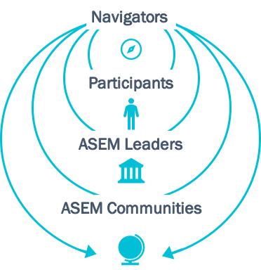

Tangible outcomes:
- An ‘ASEM Youth Report’ showcasing perceptions by young people on leadership opportunities and practices, based on a survey with youth across the 51 ASEM Partner countries
- 150 participants equipped with certificates, upon completion of a Thematic Course on Asia-Europe relations in the context of the SDGs, conducted by College of Europe Natolin; and a Leadership Training on Self, Team and Societal Leadership by the Centre of Creative Leadership
- A series of ASEM Youth Dialogues and individual meetings between youth representatives and ASEM Leaders (Heads of States and Governments), to facilitate junior-senior leadership conversations and an exchange of perspectives on the SDGs
- ASEFYLS4 e-learning platform with multi-media materials to learn about ASEM, youth leadership and Sustainable Development post-COVID19
- ASEM Youth Declaration on “ASEM Youth Leadership driving Sustainable Development in a Post-COVID-19 world” delivered at the ASEM13 Summit
- 15 Leadership in Action community activities led by youth volunteers, to promote and drive sustainable development across ASEM’s local communities
Intangible outcomes:
- Increased understanding and knowledge on the Sustainable Development and Youth Leadership through formal, non-formal and informal education and training opportunities
- Skills development and capacity building for young people, both on a technical and soft skill level
- Creation of an Asia-Europe youth network for joint volunteering and collaboration on the SDGs
- Engagement of civil society stakeholders in the official ASEM Process through participation of at 4 Youth Representatives in ASEM13
- Enhanced knowledge among the participants and increase visibility on Asia-Europe relations and ASEM
These results feed into:
- 13th ASEM Summit (ASEM13), 1-2 June 2021, Phnom Penh, Cambodia
- 8th ASEM Education Ministers’ Meeting (ASEMME8), tbc 2021, Thailand
- 15th ASEM Foreign Ministers’ Meeting (ASEMFMM15), tbc 2022, tbc Asia
In the long-term, the impact of ASEFYLS4 is two-fold:
- An enhanced Structured Dialogue between young people and political leaders to engage youth in the ASEM Process
- Enhanced connectivity among Asian and European youth through peer-to-peer exchange and joint volunteering & collaborations
ASEF & Contact Details:
The Asia-Europe Foundation (ASEF) is an intergovernmental not-for-profit organisation located in Singapore. Founded in 1997, it is the only institution of the Asia-Europe Meeting (ASEM). ASEF promotes understanding, strengthens relationships and facilitates cooperation among the people, institutions and organisations of Asia and Europe. ASEF enhances dialogue, enables exchanges and encourages collaboration across the thematic areas of culture, education, governance, economy, sustainable development, public health and media

Address:

Asia-Europe Foundation (ASEF)
31 Heng Mui Keng Terrace
119595 Singapore
www.ASEF.org
ASEFYLS4 Staff Contacts:

Partnerships:
Ms Leonie NAGARAJAN
Director
Education Department
Email: leonie.nagarajan@asef.org

Participation:
Ms Freya CHOW-PAUL
Youth Project Coordinator
Education Department
Email: asefyls@asef.orgZ

ASEFYLS4 is organised by:
Asia-Europe Foundation
Ministry of Foreign Affairs & International Cooperation (MFAIC), Kingdom of Cambodia
Ministry of Education, Youth and Sport (MOEYS), Kingdom of Cambodia
Ministry of Commerce, Kingdom of Cambodia
APSARA Authority, Cambodia
In partnership with:
Union Youth Federations of Cambodia (UYFC)
College of Europe
Center for Creative Leadership
Supported by:
Global Changemakers
Erasmus Student Network
Erasmus Student’s Union
International Association for Political Science Students
Contributing to:
13th ASEM Summit (ASEM13)
ASEF’s Contribution is made possible with the financial support of the European Union.

